**Module 1: SDLC**

1. **What is software?**

It is a collection of computer programmes and related data that provide instructions for telling a computer what to do and how to do.

* **Types of software:**
* System software
* Programming software
* Application software
* **System software:**
* System software is a type of computer program that is designed to run a computer's hardware and application programs.
* System software control and manage the operations of the computer hardware
* Ex. operating system (windows, android)
* **Programming software:**
* Programming software is software which helps the programmer in developing other software.
* Compilers , assemblers, debuggers, interpreters
* Ex. C,C++
* **Application software:**
* Application Software is a type of computer program that performs specific functions.
* Ex. Mobile app: instagram, desktop app:microsoft,web app: google

1. **What is software engineering ?**

Software engineering is a technique through which we can develop or create software for computer systems and any other electronic devices.

**>**In order to create complex software we should use software engineering techniques as well as to reduce the complextilly.

**>**We should use **obstruction** and **decomposition.**

**>Obstruction:** only important parts of software

**>Decomposition:** breakdown the software into modules where each module produces a well independent task.

* **CRS:** Customer requirement specification

>CRS is a document issued by a customer that describes the requirements of a system and the expected services of a contractor

* **SRS:** Software requirement specification

>It is describes what will be the features of software and what will be its behavior ie. how it will perform

>The SRS consists of all necessary requirements required for the project development.

1. **What is SDLC ?**

>Software development life cycle.

>The system development life cycle is also referred to as the application development life cycle is a process for planning, creating, testing and deploying information.

>SDLC is a structure imposed on the development of a software product that defines the process for **planning, implementation, testing, documentation, deployment, ongoing maintenance and support.**

>It describes the sequence of phases or steps to develop.

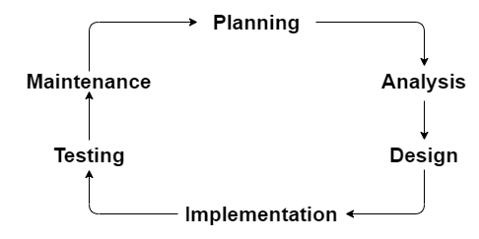

* **SDLC Phases**

| Requirements Collection/Gathering | Establish Customer Needs |
| --- | --- |
| Analysis | Model And Specify the requirements - “What” |
| Design | Model And Specify a Solution - “Why” |
| Implementation | Construct a Solution in Software |
| Testing | Validate the solution against the requirements |
| Maintenance | Repair defects and adapt the solution to the new requirements |

1. **What is DFD ?**

>DFD: **“Data Flow Diagrams”**

>DFD is a graphical representation of flow of data inside an application used for visualization data processing.

* **DFD rules**

**1) Rule 1:**each process must have data flowing into it and coming out from it.

**2) Rule 2:**Each data store must have data going inside and data coming outside.

**3) Rule 3:**A data flow out of a process should have some relevance to one or more of the data flow into a process.

**4) Rule 4:**Data stored in the system must go through a process.

**5) Rule 5:**Two data stores can’tcommunicate with each other unless a process is involved in between.

**6) Rule 6:** The process in DFD must be linked to either another process or a data store; a process can't exist by itself, unconnected to the rest of the system.

* **Create DFD diagram on flipkart**

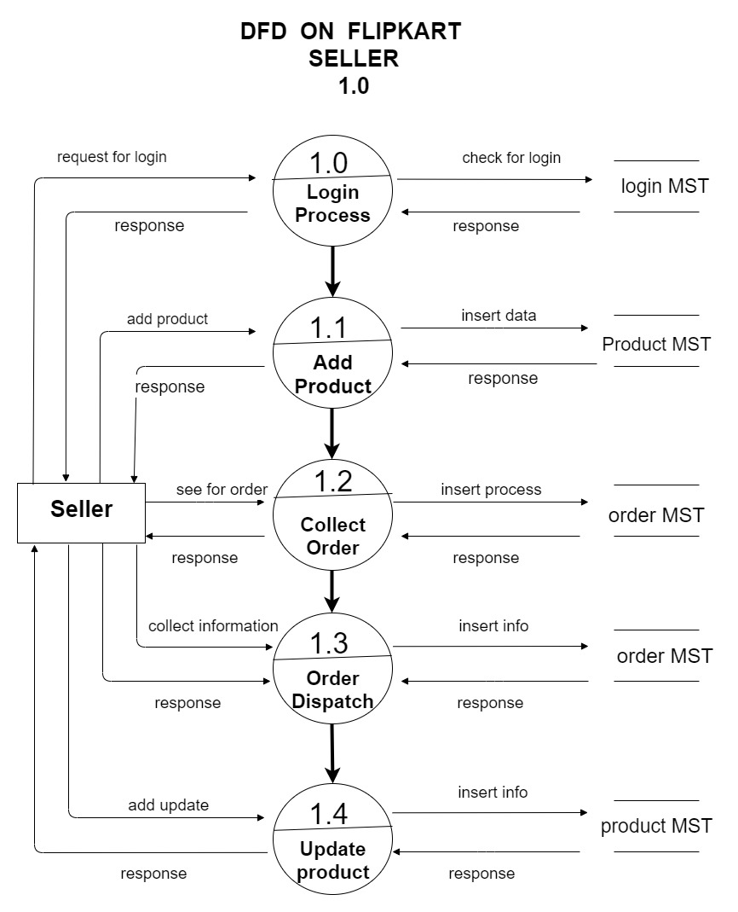

1. **What is a flow chart?**

Flowchart is a step by step representation of a problem which can be done graphically .

**>** flowchart plays a vital role in programming a problem and is quite helpful in understanding the logic of complicated and lengthy problems.

* **Programs can be in three format**

**1)** Linear or sequence

**2)** Branching

**3)**  Looping

* **Create flowchart to make addition of two number**

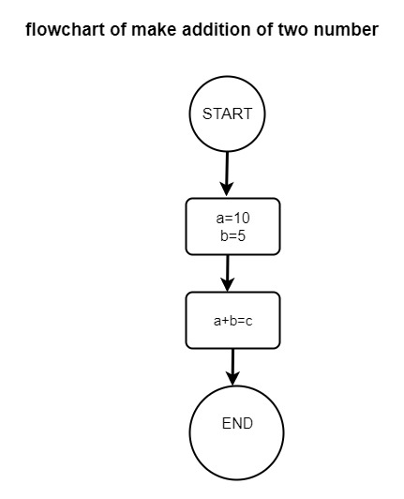

1. **What is a use case diagram?**

**UML :** Unified Modeling language

**>** It is a general purpose modeling language.

**>**  The main aim of UML is to define a standard way to visualize the way a system has been designed. It is quite similar to the blueprint used in other field of engineering .

**>** A use case diagram is a way to summarize details of a system and the users within that system. It is generally shown as a graphic depiction of interactions among different elements in a system.

* **Create a use case-case on bill payment on paytm**

